Lab Assignment 7.3: AI-Assisted Debugging – Error Detection and Fixing
Name: Suvikhyath Thirunahari
Roll No.: 2503B05202
Program: M. Tech (Ai & ml)
Date: 05-11-2025

Lab Objectives:
- Identify syntax, logic, and runtime errors in Python programs using AI tools.
- Understand common programming bugs and AI-assisted debugging suggestions.
- Evaluate how AI explains and fixes different types of coding errors.
- Improve debugging confidence using systematic debugging strategies.

Lab Outcomes:
- Use AI tools to detect and correct syntax, logic, and runtime errors.
- Interpret AI-suggested bug fixes and explanations.
- Refactor buggy code using responsible and reliable programming patterns.
- Apply structured debugging strategies supported by AI reasoning.

Task #1 — Fixing Syntax Error

Paste a function with a missing colon (add(a, b)) and let AI fix the syntax error.
Code:
def add(a, b)
return a + b
AI Debugged Code:
def add(a, b):

return a + b

print(add(5, 7))

Screenshot:

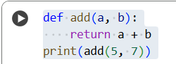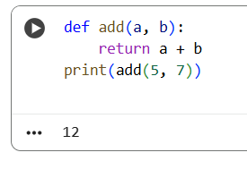
Task #2 — Debugging Loop Logic Error
Identify and fix a logic error in a loop causing infinite iteration.

Code:
i = 1
while i < 5:
print(i)

AI Debugged Code:
i = 1
while i < 5:
print(i)
i += 1

Screenshot:
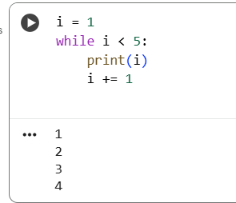
Task #3 — Handling Runtime Error
Fix division by zero using try-except.

Code:
def divide(a, b):
return a / b
print(divide(10, 0))

AI Debugged Code:
def divide(a, b):
try:
return a / b
except ZeroDivisionError:
return "Error: Cannot divide by zero."

print(divide(10, 2))
print(divide(20, 5))

Output Screenshot:
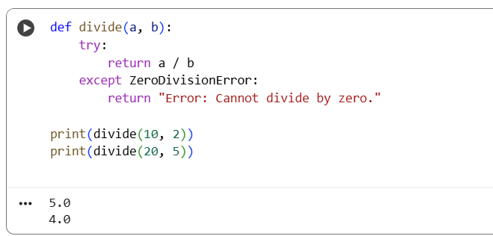
Task #4 — Debugging Class Error
Fix a faulty __init__() missing 'self' parameter.

Faulty Code:
class Student:
def __init__(name, rollno):
self.name = name
self.rollno = rollno

AI Debugged Code:
class Student:
def __init__(self, name, rollno):
self.name = name
self.rollno = rollno

def display(self):
print(f"Name: {self.name}, Roll No: {self.rollno}")

s1 = Student("Rahul", 23)
s1.display()

Output Screenshot:

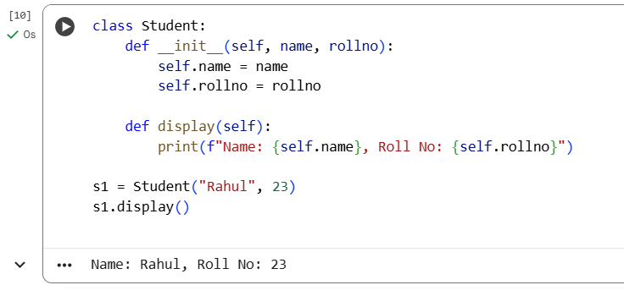Task #5 — Resolving IndexError
Access an invalid list index and use AI to fix the error.

Code:
nums = [10, 20, 30]
print(nums[5])

AI Debugged Code:
numbers = [10, 20, 30]

index = 2
if index < len(numbers):
print(numbers[index])
else:
print("Error: Index out of range. Max valid index is", len(numbers) - 1)

Screenshot:
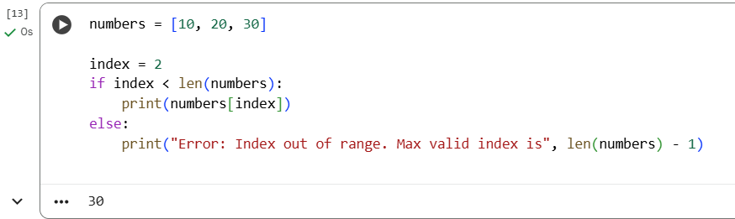
Conclusion:
In this experiment, AI assisted in debugging code by identifying syntax, logic, and runtime errors. The activity demonstrated how AI can analyze faulty code, suggest fixes, and explain errors clearly, supporting efficient debugging and improving programming accuracy.

